ORGANIC OASIS

### A Mini Project Report submitted to

**MOHAN BABU UNIVERSITY**

### in Partial Fulfillment of the Requirements for the Award of the degree of

**BACHELOR OF TECHNOLOGY IN**

### COMPUTER SCIENCE AND ENGINEERING (DATA SCIENCE)

*Submitted by*

|  |  |
| --- | --- |
| **N PUJITHA** | **(22102A030076)** |
| **O SREEJA** | **(22102A030082)** |
| **P GURU SAI RAJU** | **(22102A030089)** |

*Under the Guidance of*

### Mr. P. Yogendra Prasad

Assistant Professor

Department of Data Science



**Department of Data Science**

**SCHOOL OF COMPUTING**

**MOHAN BABU UNIVERSITY**

Sree Sainath Nagar, Tirupati – 517 102, A.P., INDIA

2024-25

**MOHAN BABU UNIVERSITY**

Sree Sainath Nagar, Tirupati – 517 102, A.P., INDIA

2024-25

**DEPARTMENT OF DATA SCIENCE**

CERTIFICATE

This is to certify that the mini project report entitled

**“ORGANIC OASIS”**

is the Bonafide work done by

|  |  |
| --- | --- |
| **N PUJITHA** | **(22102A030076)** |
| **O SREEJA** | **(22102A030082)** |
| **P GURU SAI RAJU** | **(22102A030089)** |

in the Department of **Data Science**, and submitted to Mohan Babu University, Tirupati in partial fulfillment of the requirements for the award of the degree of Bachelor of Technology in Computer Science and Engineering (Data Science) during the academic year 2024-2025. This work has been carried out under my supervision. The results of this mini project work have not been submitted to any university for the award of any degree or diploma.

***Guide: Head:***

Mr. P. Yogendra Prasad Dr. P.K. Gupta

Assistant Professor Professor & Head

Dept. of Data Science Dept. of Data Science

**INTERNAL EXAMINER EXTERNALEXAMINER**

**DEPARTMENT OF DATA SCIENCE**

**Vision**

To become a Centre of Excellence in Data Science by imparting high quality education through teaching, training and research

**Mission**

* To impart quality education in Computer Science and Engineering with specializations in Data Science by disseminating knowledge through contemporary curriculum, competent faculty and effective teaching-learning methodologies.
* Nurture research, innovation and entrepreneurial skills among students and faculty to contribute to the needs of industry and society.
* Inculcate professional attitude, ethical and social responsibilities for prospective and promising Engineering profession.
* Encourage students to engage in life-long learning by creating awareness of the contemporary developments in Computer Science and Engineering with specialization in Data Science.

**PROGRAM EDUCATIONAL OBJECTIVES**

After few years of graduation, the graduates of B. Tech. CSE(DS) will:

|  |  |
| --- | --- |
| **PEO1.** | Pursue higher studies in Computer Science, Data science or Management. |
| **PEO2.** | Become successful entrepreneurs or be employed by acquiring required skill sets in the domains of Data Science and allied areas. |
| **PEO3.** | Exhibit progression and effective adaptation to technological developments through life-long learning to address ever changing industrial requirements and follow ethical attitude in professional practice. |

**PROGRAM SPECIFIC OUTCOMES**

On successful completion of the Program, the graduates of B. Tech. CSE(DS) program will be able to:

|  |  |
| --- | --- |
| **PSO1.** | Apply appropriate data analytical techniques for building effective decision-making systems. |
| **PSO2.** | Develop intelligent systems using novel Machine Learning and Artificial Intelligence techniques. |
| **PSO3.** | Design and develop efficient software systems using modern tools, techniques, and platforms to meet societal needs. |
| **PSO4.** | Apply suitable tools and techniques to build secure distributed systems. |

**PROGRAM OUTCOMES**

On successful completion of the Program, the graduates of B.Tech. CSE (DS) Program will be able to:

|  |  |
| --- | --- |
| **PO1.** | **Engineering knowledge**: Apply the knowledge of mathematics, science, engineering fundamentals, and an engineering specialization to the solution of complex engineering problems. |
| **PO2.** | **Problem analysis**: Identify, formulate, review research literature, and analyze complex engineering problems reaching substantiated conclusions using first principles of mathematics, natural sciences, and engineering sciences. |
| **PO3.** | **Design/development of solutions**: Design solutions for complex engineering problems and design system components or processes that meet the specified needs with appropriate consideration for the public health and safety, and the cultural, societal, and environmental considerations. |
| **PO4.** | **Conduct investigations of complex problems**: Use research-based knowledge and research methods including design of experiments, analysis and interpretation of data, and synthesis of the information to provide valid conclusions. |
| **PO5.** | **Modern tool usage**: Create, select, and apply appropriate techniques, resources, and modern engineering and IT tools including prediction and modeling to complex engineering activities with an understanding of the limitations. |
| **PO6.** | **The engineer and society**: Apply reasoning informed by the contextual knowledge to assess societal, health, safety, legal and cultural issues and the consequent responsibilities relevant to the professional engineering practice. |
| **PO7.** | **Environment and sustainability**: Understand the impact of the professional engineering solutions in societal and environmental contexts, and demonstrate the knowledge of, and need for sustainable development. |
| **PO8.** | **Ethics**: Apply ethical principles and commit to professional ethics and responsibilities and norms of the engineering practice. |
| **PO9.** | **Individual and team work**: Function effectively as an individual, and as a member or leader in diverse teams, and in multidisciplinary settings. |
| **PO10.** | **Communication**: Communicate effectively on complex engineering activities with the engineering community and with society at large, such as, being able to comprehend and write effective reports and design documentation, make effective presentations, and give and receive clear instructions. |
| **PO11.** | **Project management and finance**: Demonstrate knowledge and understanding of the engineering and management principles and apply these to one’s own work, as a member and leader in a team, to manage projects and in multidisciplinary environments. |
| **PO12.** | **Life-long learning**: Recognize the need for, and have the preparation and ability to engage in independent and life-long learning in the broadest context of technological change. |

# DECLARATION

We hereby declare that this project report titled **“Organic Oasis”** is a genuine work carried out by us, in **B-Tech *(Computer Science and Engineering (Data Science))*** degree course of **Mohan Babu University, Tirupati** and has not been submitted to any other course or University for the award of any degree by us.

We declare that this written submission represents our ideas in our own words and where others' ideas or words have been included, we have adequately cited and referenced the original sources. We also declare that we have adhered to all principles of academic honesty and integrity and have not misrepresented or fabricated or falsified any idea / data / fact / source in our submission. We understand that any violation of the above will cause for disciplinary action by the Institute and can also evoke penal action from the sources which have thus not been properly cited or from whom proper permission has not been taken when needed.

Signature of the students

## ABSTRACT

"Organic" or "organically grown" foods are commonly represented as "food grown without pesticides; grown without artificial fertilizers; grown in soil whose humus content is increased by the additions of organic matter; grown in soil whose mineral content is increased with applications of natural mineral fertilizers; has not been treated with preservatives, antibiotics etc… Organic food products and other organic ingredients are grown without the use of pesticides, synthetic fertilizers, sewage sludge, or ionizing radiation. Conventional fruits and vegetables are often sprayed with pesticides. When you buy such fruits and vegetables, these stubborn chemicals remain on the food. The second big difference between conventional and organic food is that many conventional foods are genetically modified or contain genetically modified organisms. Organic food is not easily available in the market. There are only some particular shops where organic food is available. To overcome the difficulty of organic food shopping. “Organic Oasis” Projects has proposed a best online organic store which provides organic foods by just sitting at home and follows E-commerce mode of shopping. This system has two modules namely, Admin and Customers. Admin has authority to add organic food list on the website, view products uploaded, view customers and view the customer's order. Customers can register and login using credentials. Customers has authority to view products, desire products and can add to cart and do payment for it, they can view their previous order history and also can track their order.

***Keywords:*** Organic Grown, conventional, Artificial Fertilizers, HTML, JAVASCRIPT, PHP.

i

## TABLE OF CONTENTS

|  |  |
| --- | --- |
| **Title** | **Page No.** |
| ABSTRACT | i |
| **CHAPTER 1: INTRODUCTION** | 2 |
| INTRODUCTION | 2 |
| STATEMENT OF THE PROBLEM | 3 |
| OBJECTIVES | 4 |
| LIMITATIONS | 4 |
| **CHAPTER 2: METHODOLOGY** | 5 |
| **CHAPTER 3: SYSTEM DESIGN** | 6 |
| REQUIREMENTS | 6 |
| SYSTEM DESIGN | 6 |
| TECHNOLOGIES USED | 7 |
| **CHAPTER 4: IMPLEMENTATION** | 8 |
| **CHAPTER: 5 PROPOSED SYSTEM ARCHITECTURE** | 9 |
| FLOW CHART | 10 |
| **CHAPTER 6: CODING AND RESULT** | 11 |
| CODE | 11 |
| RESULT | 35 |
| **CHAPTER 7: CONCLUSION AND FUTURE WORK** | 41 |
| CONCLUSION | 41 |
| FUTURE WORK | 41 |

**CHAPTER- 1 INTRODUCTION**

### Introduction:

This report presents a pioneering website developed using advanced technologies to offer comprehensive information about the finest fresh and organic fruits and vegetables available. Our platform is dedicated to providing users with detailed insights into the benefits, sources, and seasonal availability of organic produce, enabling them to make informed and healthy dietary choices.

At Organic Oasis, we know that Our website is designed to be your ultimate guide to understanding and embracing the goodness of organic produce. With a user-friendly interface and robust search capabilities, Organic Oasis ensures that you can easily access: Detailed Produce Information, Seasonal Guides, Sustainability Insights. We believe in the power of pure, unadulterated produce straight from the heart of nature. Our selection is hand-picked from certified organic farms dedicated to sustainable practices and eco-friendly cultivation methods.

Our goal is to help you navigate the world of organic produce with confidence. Whether you're looking to incorporate more fruits and vegetables into your diet, or seeking specific organic products, Organic Oasis is your trusted companion. Explore our curated lists, expert tips, and engaging content to make the most of your organic lifestyle. Join us at Organic Oasis and embark on a journey towards healthier, more sustainable eating. Your well-being and the health are just a click away! .

### Problem Statement:

The fact that consumers often struggle to find reliable sources of information on fresh and organic produce presents significant challenges. The fragmentation of available resources makes it difficult to gather up-to-date information on organic fruits and vegetables, consumers' ability to make informed dietary choices and access quality organic products. Therefore, there is a need for a user-friendly website that provides comprehensive, detailed information about fresh and organic produce to increase accessibility and offer reliable resources for health-conscious consumers.When developing Organic Oasis, we encountered issues during testing, coding, and integration of various functionalities, as well as challenges in implementing specific guidelines and regulations. Nonetheless, our commitment to delivering an intuitive, informative platform ensures that users can easily navigate the world of organic produce, enhancing their shopping experience and promoting healthier eating habits.

### Objectives:

The main objective of the Project is to provide users with a central hub for all their fresh and organic produce needs, helping them make informed dietary choices by offering detailed information on a variety of fruits and vegetables.

The objectives are:

* Centralize Information.
* Enhance Accessibility.
* Provide Comprehensive Details.
* Promote Lesser-Known Produce.
* Ensure Responsive Design.
* Encourage Healthy Eating.

### Limitations:

* Supply chain reliability
* Consumer awareness and Quality assurance
* Environmental impact and User trust

## CHAPTER – 2 METHODOLOGY

Organic Oasis aims to provide a reliable, comprehensive, user-friendly website and accessible platform for consumers seeking fresh and organic produce. Despite challenges during development, our commitment to quality and user satisfaction will guide us in creating a valuable resource for healthier and more sustainable eating. The website will serve as a central hub for consumers to make informed dietary choices. During development, we will address challenges related to data collection, testing, coding, and integration of functionalities, while ensuring compliance with relevant guidelines and regulations.

## CHAPTER – 3 SYSTEM DESIGN

### Requirements:

The user should have the appropriate version of windows.

* The system should have up to 1 GB ram minimum requirement for theapplication.
* Internet Connectivity is a must for this purpose.

### System Design:

The website is designed to provide a user-friendly and well-structured experience, ensuring a smooth browsing process. The following sections describe the main content and structure of the site:

**HOME PAGE**: The home page welcomes users to Organic Oasis with attractive banners showcasing vibrant images of fresh and organic produce. It also provides a search bar and a menu for easy navigation to various sections of the website.

**PRODUCTS CATEGORIES**: The website is organized into different product categories, such as fruits, vegetables, and seasonal produce. Users can navigate to their desired category from the menu or the search function. Each category page includes a brief summary of the products available, their health benefits, and a list of featured items.

**PRODUCT PAGES**: Each type of fruit and vegetable has its own dedicated page. These pages provide detailed information about the produce, including nutritional benefits, sourcing, seasonal availability, and sustainable farming practices. The pages are enriched with high-quality images and interactive features to enhance the user experience.

**RESPONSIVE DESIGN**: The website is designed to be responsive and functional across a variety of devices, including desktop computers, tablets, and mobile phones. The layouts adapt seamlessly to different screen sizes, ensuring accessibility and usability as users navigate the site.

### Technologies used:

The website is developed using modern front-end technologies to create an engaging, dynamic, and user-friendly interface. The key technologies employed in the development of this website include:

**HTML5**: The structure and content of the website are created using HTML5, ensuring semantic markup and proper organization of information..

**CSS3**: CSS3 is used for styling and visual presentation of the website, including layout design, color schemes, typography, and responsive elements.

**JAVASCRIPT**: JavaScript is utilized to implement interactive features such as search functionality, user reviews, interactive elements, and dynamic content loading.

## CHAPTER - 4 IMPLEMENTATION

The implementation of the project involves several crucial stages to create a comprehensive website dedicated to fresh and organic fruits and vegetables. The process begins with a thorough needs analysis to understand the project’s objectives, target audience, and necessary features. This analysis forms the foundation for gathering detailed information about organic produce, including nutritional benefits, sources, and sustainability practices. Following this, design phase ensures that the website is both visually appealing and user-friendly, with clear layouts and consistent designs across different devices.

Front-end development utilizes technologies such as HTML5, CSS3, and JavaScript to bring the visual content, interactive features, and user interface to life. The collected data is organized into a structured database. The back-end development involves using server-side languages like PHP, Python, or Node.js to handle data interactions and support dynamic content. Quality testing and assurance are integral parts of the process, ensuring the website functions correctly, is user-friendly, and is compatible with various browsers..

## CHAPTER-5

**PROPOSED SYSTEM ARCHITECTURE**

The system architecture for the website follows a layered approach. At the presentation layer, the user interface is developed using HTML5, CSS3, and JavaScript, ensuring a visually appealing and responsive design across various devices. The application layer handles the business logic and processes user requests, utilizing frameworks such as React or Angular along with server-side languages like PHP, or Python. This layer ensures smooth execution of functionalities like search operations, user authentication, and dynamic content loading. The data access layer interacts with the underlying database, using technologies like MySQL, MongoDB, to perform data retrieval and storage efficiently. This structure supports the secure and efficient management of information related to organic produce and user profiles.

### 5.1 Flow Chart:

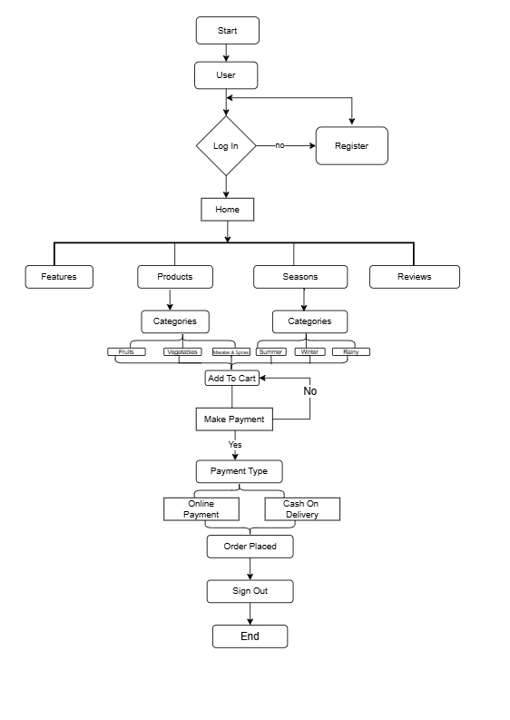

**Fig. demonstration of the website**

## CHAPTER-6

**CODING ANALYSIS AND RESULTS**

### Code:

1. **Login Page:**

<!DOCTYPE html>

<html lang="en">

<head>

<meta charset="UTF-8">

<meta name="viewport" content="width=device-width, initial-scale=1.0">

<title>Oasis Login Page</title>

<style>

body

{

margin: 0;

padding: 0;

font-family: montserrat;

background: url('./image/form.jpg') no-repeat;

background-size:110rem 50rem;

height: 100vh;

overflow: hidden;

}

.center

{

position: absolute;

top: 50%;

left: 50%;

transform: translate(-50%, -50%);

width: 400px;

background-size: cover;

border-radius: 10px;

}

.center h1

{

text-align: center;

padding: 0 0 20px 0;

border-bottom: 1px solid silver;

}

.center form

{

padding: 0 40px;

box-sizing: border-box;

}

form .txt_field{

position: relative;

border-bottom: 2px solid #adadad;

margin: 30px 0;

}

.txt_field input

{

width: 100%;

padding: 0 5px;

height: 40px;

font-size: 16px;

border: none;

background: none;

outline: none;

}

.txt_field label

{

position: absolute;

top: 50%;

left: 5px;

color: #a6a6a6;

transform: translateY(-50%);

font-size: 16px;

pointer-events: none;

transition: .5s;

}

.txt_field span::before

{

content: '';

position: absolute;

top: 40px;

left: 0;

width: 0%;

height: 2px;

background: #2691d9;

transition: .5s;

}

.txt_field input:focus ~ label,

.txt_field input:valid ~ label{

top: -5px;

color: #2691d9;

}

.txt_field input:focus ~ span::before

.txt_field input:valid ~ span::before{

width: 100%;

}

.pass

{

margin: -5px 0 20px 5px;

color: #a6a6a6;

cursor: pointer;

}

.pass:hover

{

text-decoration: underline;

}

button[type="submit"]

{

width: 100%;

height: 50px;

border: 1px solid;

background: #2691d9;

border-radius: 25px;

font-size: 18px;

color: #e9f4fb;

font-weight: 700;

cursor: pointer;

outline: none;

}

button[type="submit"]:hover

{

border-color: #2691d9;

transition: .5s;

}

.signup_link

{

margin: 30px 0;

text-align: center;

font-size: 16px;

color: #666666;

}

.signup_link a

{

color: #2691d9;

text-decoration: none;

}

.signup_link a:hover

{

text-decoration: underline;

}

</style>

</head>

<body>

<div class="center">

<h1>WELCOME</h1>

<form class="login-form">

<div class="txt_field" required>

<input type="email" placeholder="email" >

<span></span>

<label ></label>

</div>

<div class="txt_field" required>

<input type="password" placeholder="password" >

<label ></label>

</div>

<div class="pass">Forgot Password?</div>

<button type="submit">

<a href="index1.html" >Login</a>

</button>

<div class="signup_link">

Not a member? <a href="Registration.html">Signup</a>

</div>

</form>

</div>

</body>

</html>>

### Home Page:

<!DOCTYPE html>

<html lang="en">

<head>

<meta charset="UTF-8">

<meta name="viewport" content="width=device-width, initial-scale=1.0">

<title>Organic Oasis</title>

<style>

:root

{

--green: green;

--black: #130f40;

--light-color:#666;

--box-shadow:0 .5rem 1.5rem rgba(0,0,0,.1);

--border: 2rem solid rgba(0,0,0.1);

--outline: 1rem solid rgba(0,0,0.1);

}

*

{

font-family: "Poppins", sans-serif;

margin: 0;

padding: 0;

box-sizing: border-box;

outline: none;

border: none;

text-decoration: none;

text-transform: capitalize;

transition: all .2s linear;

}

html{

font-size: 62.5%;

overflow-x: hidden;

scroll-behavior: smooth;

scroll-padding-top: 7rem;

}

body{

background: #eee;

}

/*css code for banner*/

section

{

padding: 2rem 9%;

}

.heading

{

text-align: center;

padding: 2rem 0;

padding-bottom: 3rem;

font-size: 3.5rem;

color: var(--black);

}

.heading span{

background: var(--green);

color: #fff;

display: inline-block;

padding: .5rem 3rem;

clip-path: polygon(100% 0,93% 50%, 100% 99%, 0% 100%, 7% 50%, 0% 0%);

}

.btn

{

border: .2rem solid var(--black);

margin-top: 1rem;

display: inline-block;

padding: .8rem 3rem;

font-size: 1.7rem;

border-radius: .5rem ;

color: var(--black);

cursor: pointer;

background:none;

}

.btn:hover

{

background: var(--green);

color: #fff;

}

.header

{

border:0px solid;

position: fixed;

top:0;

left:0;

right:0;

z-index: 1000;

display: flex;

align-items: center;

justify-content: space-between;

padding: 2rem 9%;

background: #fff;

box-shadow: var(--box-shadow);

}

.header .logo

{

font-size: 2.5rem;

font-weight: bolder;

background-image: url('');

}

.header .logo i

{

color: var(--green);

}

.header .navbar a

{

font-size: 1.7rem;

margin: 0 1rem;

color:var(--black);

}

.header .navbar a:hover

{

color: var(--green);

}

.header .icons div

{

border: 0px solid;

height: 4.5rem;

width: 4.5rem;

line-height: 4.5rem;

border-radius: .5rem;

background: #eee;

color: var(--black);

font-size: 2rem;

margin-right: .3rem;

text-align: center;

cursor: pointer;

}

.header .icons div:hover

{

background: var(--green);

color: white;

}

</style>

</head>

<body>

<!--header section-->

<header class="header">

<div>

<p><img src="image/logo.jpeg" width="80rem"></p>

</div>

<nav class="navbar">

<a href="#home">home</a>

<a href="#features">features</a>

<a href="#products">products</a>

<a href="#seasons">seasons</a>

<a href="#review">review</a>

</nav>

<div class="icons">

<div class="fa fa-bars" id="menu-btn"></div>

<div class="fa fa-search" id="search-btn"></div>

<div class="fa fa-user" id="login-btn"></div>

<div class="fa fa-sign-out" id="logout-btn"></div>

</div>

<form class="search-form">

<input type="search" id="search-form" placeholder="Search Here....">

<label for="search-form" class="fa fa-search"></label>

</form>

<form action="#" class="login-form">

<h3><a href="Oasis login.html">Login Now</a></h3>

</form>

<form action="#" class="logout-form">

<h3><a href="Oasis login.html">Logout</a></h3>

</form>

</header>

<!--header section-->

<!--banner section-->

<section class="home" id="home">

<div class="content">

<h3>Fresh and <span>Organic</span> Products For You</h3>

<p>At Organic Oasis, we are passionate about helping you achieve your wellness goals.

Whether you have questions about our products or want to share your experience,

we would love to hear from you. Feel free to contact us anytime via email or contact us.

</p>

</div>

</section>

<!--banner section-->

<!--features section-->

<section class="features" id="features">

<h1 class="heading"> our <span>features</span> </h1>

<div class="box-container">

<div class="box">

<img src="/image/feature-img-1.png" alt="">

<h3>fresh and organic</h3>

<p>Products are Organic and Fresh</p>

</div>

<div class="box">

<img src="/image/feature-img-2.png" alt="">

<h3>free delivery</h3>

<p>free shipping delivery to door</p>

</div>

<div class="box">

<img src="/image/feature-img-3.png" alt="">

<h3>easy payments</h3>

<p>make an payments easily through online</p>

</div>

</div>

</section>

<!--features section-->

<!--products section-->

<section class="products" id="products">

<h1 class="heading"> our <span>products</span> </h1>

<div class="box-container">

<div class="box">

<img src="/image/veg.jpg" alt="">

<h3>vegetabels</h3>

<p>upto 40% off</p>

<a href="vegetables.html" class="btn">shop now</a>

</div>

<div class="box">

<img src="/image/fruit.jpeg" alt="">

<h3>fruits</h3>

<p> upto 55% off</p>

<a href="fruits.html" class="btn">shop now</a>

</div>

<div class="box">

<img src="/image/powder.png" alt="">

<h3>masala & spices</h3>

<p> upto 30% off</p>

<a href="masalapowders.html" class="btn">shop now</a>

</div>

</div>

</section>

<!--products section-->

<!--season section-->

<section class="seasons" id="seasons">

<h1 class="heading"> seasonal <span>products</span> </h1>

<div class="box-container">

<div class="box">

<img src="/image/summer.jpg" alt="">

<h3>summer</h3>

<p>upto 40% off</p>

<a href="summer.html" class="btn">shop now</a>

</div>

<div class="box">

<img src="/image/rainy.png" alt="">

<h3>rainy</h3>

<p>upto 55% off</p>

<a href="rainy.html" class="btn">shop now</a>

</div>

<div class="box">

<img src="/image/winter.png" alt="">

<h3>winter</h3>

<p>upto 30% off</p>

<a href="winter.html" class="btn">shop now</a>

</div>

</div>

</section>

<!--season section-->

<!--review section-->

<section class="review" id="review">

<h1 class="heading"> customer's <span>review</span> </h1>

<div class="swiper review-slider">

<div class="swiper-wrapper">

<div class="swiper-slide box">

<img src="image/pic-1.png" alt="">

<p>I love Organic Oasis! Their products are always fresh and high quality. It's my go to spot for healthy, organic groceries.</p>

<h3>pavan</h3>

<div class="stars">

<i class="fa fa-star"></i>

<i class="fa fa-star"></i>

<i class="fa fa-star"></i>

<i class="fa fa-star"></i>

<i class="fa fa-star-half"></i>

</div>

</div>

<div class="swiper-slide box">

<img src="image/pic-2.png" alt="">

<p>Organic Oasis has everything I need for my clean eating lifestyle. I always find new and exciting organic options here..</p>

<h3>sita</h3>

<div class="stars">

<i class="fa fa-star"></i>

<i class="fa fa-star"></i>

<i class="fa fa-star"></i>

<i class="fa fa-star"></i>

<i class="fa fa-star-half"></i>

</div>

</div>

<div class="swiper-slide box">

<img src="image/pic-3.png" alt="">

<p>The best store for organic food lovers. The variety of fresh fruits and vegetables is unbeatable, and everything is reasonably priced.</p>

<h3>raju</h3>

<div class="stars">

<i class="fa fa-star"></i>

<i class="fa fa-star"></i>

<i class="fa fa-star"></i>

<i class="fa fa-star"></i>

<i class="fa fa-star-half"></i>

</div>

</div>

<div class="swiper-slide box">

<img src="image/pic-4.png" alt="">

<p>I appreciate how much care Organic Oasis puts into sourcing their products. Everything is top-notch, and I feel good shopping here.</p>

<h3>geethu</h3>

<div class="stars">

<i class="fa fa-star"></i>

<i class="fa fa-star"></i>

<i class="fa fa-star"></i>

<i class="fa fa-star"></i>

<i class="fa fa-star-half"></i>

</div>

</div>

</div>

</div>

</section>

<!--review section-->

<!--footer section-->

<section class="footer">

<div class="box-container">

<div class="box">

<h3> Oasis <i class="fa fa-shopping-basket"></i></h3>

<p>Great selection of organic produce and eco-friendly products.

The staff is always helpful and friendly.</p>

<div class="share">

<a href="#" class="fa fa-facebook"></a>

<a href="#" class="fa fa-instagram"></a>

<a href="#" class="fa fa-twitter"></a>

<a href="#" class="fa fa-linkedin"></a>

</div>

</div>

<div class="box">

<h3> Contact Info </h3>

<a href="#" class="links"><i class="fa fa-phone"></i> +91 9876543210</a>

<a href="#" class="links"><i class="fa fa-phone"></i> +91 9876554321</a>

<a href="#" class="links"><i class="fa fa-envelope"></i> info@gmail.com</a>

<a href="#" class="links"><i class="fa fa-map-marker"></i> Tirupati, India</a>

</div>

<div class="box">

<h3> Quick Links </h3>

<a href="#" class="links"><i class="fa fa-arrow-right"></i> Home</a>

<a href="#" class="links"><i class="fa fa-arrow-right"></i> Features</a>

<a href="#" class="links"><i class="fa fa-arrow-right"></i> Products</a>

<a href="#" class="links"><i class="fa fa-arrow-right"></i> Seasons</a>

<a href="#" class="links"><i class="fa fa-arrow-right"></i> Review</a>

</div>

<div class="box">

<img src="image/logo.jpeg" class="page-img">

<img src="image/payment.png" class="payment-img">

</div>

</div>

<div class="credit">Created By <span>Organic Oasis</span> | All Rights Reserved</div>

</section>

<!--footer section-->

<script >

let searchForm = document.querySelector('.search-form');

document.querySelector('#search-btn').onclick =() =>

{

searchForm.classList.toggle('active');

loginForm.classList.remove('active');

logoutForm.classList.remove('active');

navbar.classList.remove('active');

}

let loginForm = document.querySelector('.login-form');

document.querySelector('#login-btn').onclick =() =>

{

loginForm.classList.toggle('active');

searchForm.classList.remove('active');

logoutForm.classList.remove('active');

navbar.classList.remove('active');

}

let logoutForm = document.querySelector('.logout-form');

document.querySelector('#logout-btn').onclick = () => {

logoutForm.classList.toggle('active');

loginForm.classList.remove('active');

searchForm.classList.remove('active');

navbar.classList.remove('active');

};

let navbar = document.querySelector('.navbar');

document.querySelector('#menu-btn').onclick =() =>

{

navbar.classList.toggle('active');

searchForm.classList.remove('active');

loginForm.classList.remove('active');

logoutForm.classList.remove('active');

}

window.onscroll = () =>

{

searchForm.classList.remove('active');

loginForm.classList.remove('active');

logoutForm.classList.remove('active');

navbar.classList.remove('active');

}

var swiper = new Swiper(".review-slider", {

spaceBetween: 20,

autoplay: {

delay: 1500,

},

breakpoints: {

0: {

slidesPerView: 1,

},

768: {

slidesPerView: 2,

},

1020: {

slidesPerView: 3,

},

},

});

</script>

</body>

</html>>

### Registration Page:

<!DOCTYPE html>

<html lang="en">

<head>

<meta charset="UTF-8" />

<meta name="viewport" content="width=device-width, initial-scale=1.0" />

<meta http-equiv="X-UA-Compatible" content="ie=edge" />

<title>Registration Form</title>

<style>

*

{

margin: 0;

padding: 0;

box-sizing: border-box;

font-family: "Poppins", sans-serif;

}

body

{

min-height: 100vh;

display: flex;

align-items: center;

justify-content: center;

padding: 20px;

background: url(./image/ban.jpg) no-repeat;

background-size: 110rem 60rem;

}

.container

{

position: relative;

max-width: 700px;

width: 100%;

background:#fff;

background-size: cover;

color: #fff;

padding: 25px;

border-radius: 8px;

box-shadow: 0 0 15px rgba(0, 0, 0, 0.1);

}

.container h1 {

font-size: 1.5rem;

color:black;

font-weight: 500;

text-align: center;

}

.container .form {

margin-top: 40px;

}

.input-box input:focus {

box-shadow: 0 1px 0 rgba(0, 0, 0, 0.1);

}

.form .input-box {

width: 100%;

margin-top: 20px;

}

.input-box label {

color: black;

}

.form :where(.input-box input, .select-box) {

position: relative;

height: 50px;

width: 100%;

outline: none;

font-size: 1rem;

color: #707070;

margin-top: 8px;

border: 1px solid #ddd;

border-radius: 6px;

padding: 0 15px;

}

.form .column {

display: flex;

column-gap: 15px;

}

.form .gender-box {

margin-top: 20px;

}

.gender-box h3 {

color: black;

font-size: 1rem;

font-weight: 400;

margin-bottom: 8px;

}

.form :where(.gender-option, .gender) {

display: flex;

align-items: center;

column-gap: 50px;

flex-wrap: wrap;

}

.form .gender {

column-gap: 5px;

}

.gender input {

accent-color: rgb(130, 106, 251);

}

.form :where(.gender input, .gender label) {

cursor: pointer;

}

.gender label {

color: black;

}

.address :where(input, .select-box) {

margin-top: 15px;

}

.select-box select {

height: 100%;

width: 100%;

outline: none;

border: none;

color: #707070;

font-size: 1rem;

}

.form button {

height: 50px;

width: 50%;

color: #fff;

font-size: 1rem;

font-weight: 400;

margin-top: 30px;

border: none;

cursor: pointer;

transition: all 0.2s ease;

background: rgb(130, 106, 251);

}

.form button:hover {

background: rgb(88, 56, 250);

}

</style>

</head>

<body>

<section class="container">

<h1>Registration Form</h1>

<form action="database.php" method="POST" class="form">

<div class="input-box">

<label>full Name</label>

<input type="text" name="name" placeholder="Enter full name" required>

</div>

<div class="input-box">

<label>email</label>

<input type="email" name="email" placeholder="Enter email address" required>

</div>

<div class="input-box">

<label>password</label>

<input type="password" name="password" placeholder="Password" required>

</div>

<div class="column">

<div class="input-box">

<label>phone</label>

<input type="number" name="phone" placeholder="Enter phone number" required >

</div>

</div>

<button type="submit">

Submit

</button>

</form>

</section>

</body>

</html>

**Php:**

<?php

ini_set('display_errors', 1);

error_reporting(E_ALL);

if ($_SERVER["REQUEST_METHOD"] == "POST") {

$conn = new mysqli("localhost", "root", "", "organicoasis");

if ($conn->connect_error) {

die("Connection failed: " . $conn->connect_error);

}

$full_name = $conn->real_escape_string($_POST['name']);

$email = $conn->real_escape_string($_POST['email']);

$password = password_hash($_POST['password'], PASSWORD_DEFAULT);

$phone = $conn->real_escape_string($_POST['phone']);

$sql = "INSERT INTO user (full_name, email, password, phone) VALUES ('$full_name', '$email', '$password', '$phone')";

if ($conn->query($sql) === TRUE) {

header("Location: Oasis login.html");

exit();

} else {

echo "Error: " . $sql . "<br>" . $conn->error;

}

$conn->close();

}

?>

### Products & Seasonal Page:

1. **Products** :

<!DOCTYPE html>

<html lang="en">

<head>

<meta charset="UTF-8">

<meta name="viewport" content="width=device-width, initial-scale=1.0">

<title>Vegetable</title>

<style>

body {

font-family: Arial, sans-serif;

margin: 0;

padding: 0;

background-color: #f4f4f4;

}

header {

background: url(/image/ban.jpg) no-repeat;

background-size: cover;

color: black;

text-align: center;

padding: 2rem;

height: 20rem;

}

header p img {

text-align: center;

height: 20rem;

width: 28rem;

}

main {

display: flex;

padding: 2rem;

}

.content {

flex: 3;

}

aside {

flex: 1;

margin-left: 2rem;

background-color: white;

padding: 1rem;

border: 1px solid #ddd;

position: sticky;

top: 0;

height: fit-content;

}

.store {

display: flex;

flex-wrap: wrap;

gap: 2rem;

justify-content: space-between;

}

.product {

background-color: white;

border: 1px solid #ddd;

padding: 1rem;

text-align: center;

flex: 1 1 calc(33.33% - 2rem);

box-sizing: border-box;

}

.product img {

max-width: 100%;

height: auto;

}

aside {

margin-top: 2rem;

background-color: white;

padding: 1rem;

border: 1px solid #ddd;

}

button {

background-color: #4caf50;

color: white;

border: none;

padding: 0.5rem;

cursor: pointer;

}

button:hover {

background-color: #45a049;

}

#cart-list {

list-style: none;

padding: 0;

}

#cart-list li {

margin: 0.5rem 0;

}

.remove-button {

background-color: #f44336;

color: white;

border: none;

padding: 0.3rem 0.5rem;

margin-left: 1rem;

cursor: pointer;

}

.remove-button:hover {

background-color: #e53935;

}

.cancel-button {

display: block;

background-color: #f44336;

color: white;

padding: 0.75rem;

border: none;

border-radius: 5px;

text-align: center;

text-decoration: none;

margin: 1rem auto;

width: 100px;

}

.cancel-button:hover {

background-color: #e53935;

}

</style>

</head>

<body>

<header>

<div>

<p><img src="image/veg1.png" width="80rem"></p>

</div>

</header>

<main>

<div class="content">

<div class="store">

<div class="product" data-name="Tomato" data-price="50">

<img src="image/tomato.jpeg" alt="Tomato">

<h3>Tomato 1kg</h3>

<p>Price: ₹50</p>

<button onclick="addToCart('Tomato 1kg', 50)">Add to Cart</button>

</div>

<div class="product" data-name="Potato" data-price="40">

<img src="image/potato.jpeg" alt="Potato">

<h3>Potato 1kg</h3>

<p>Price: ₹40</p>

<button onclick="addToCart('Potato 1kg', 40)">Add to Cart</button>

</div>

<div class="product" data-name="Carrot" data-price="60">

<img src="image/carrot.jpeg" alt="Carrot">

<h3>Carrot 1kg</h3>

<p>Price: ₹60</p>

<button onclick="addToCart('Carrot 1kg', 60)">Add to Cart</button>

</div>

<div class="product" data-name="Cucumber" data-price="50">

<img src="image/cucumber.jpeg" alt="Cucumber">

<h3>Cucumber 1kg</h3>

<p>Price: ₹50</p>

<button onclick="addToCart('Cucumber 1kg', 50)">Add to Cart</button>

</div>

<div class="product" data-name="Onion" data-price="40">

<img src="image/onion.jpeg" alt="Onion">

<h3>Onion 1kg</h3>

<p>Price: ₹40</p>

<button onclick="addToCart('Onion 1kg', 40)">Add to Cart</button>

</div>

<div class="product" data-name="Bottlegourd" data-price="32">

<img src="image/bottlegourd.jpeg" alt="Bottlegourd">

<h3>Bottlegourd 1kg</h3>

<p>Price: ₹32</p>

<button onclick="addToCart('Bottlegourd 1kg', 32)">Add to Cart</button>

</div>

<div class="product" data-name="Radish" data-price="26">

<img src="image/radish.jpeg" alt="Radish">

<h3>Radish 1kg</h3>

<p>Price: ₹26</p>

<button onclick="addToCart('Radish 1kg', 26)">Add to Cart</button>

</div>

<div class="product" data-name="Cabbage" data-price="20">

<img src="image/cabbage.jpeg" alt="Cabbage">

<h3>Cabbage 1kg</h3>

<p>Price: ₹20</p>

<button onclick="addToCart('Cabbage 1kg', 20)">Add to Cart</button>

</div>

<div class="product" data-name="GreenBeans" data-price="80">

<img src="image/greenbeans.jpeg" alt="GreenBeans">

<h3>GreenBeans 1kg</h3>

<p>Price: ₹80</p>

<button onclick="addToCart('GreenBeans 1kg', 80)">Add to Cart</button>

</div>

<div class="product" data-name="Beetroot" data-price="40">

<img src="image/beetroot.jpeg" alt="Beetroot">

<h3>Beetroot 1kg</h3>

<p>Price: ₹40</p>

<button onclick="addToCart('Beetroot 1kg', 40)">Add to Cart</button>

</div>

<div class="product" data-name="Bringal" data-price="75">

<img src="image/bringal.jpeg" alt="Bringal">

<h3>Bringal 1kg</h3>

<p>Price: ₹75</p>

<button onclick="addToCart('Bringal 1kg', 75)">Add to Cart</button>

</div>

<div class="product" data-name="Greenchilli" data-price="45">

<img src="image/mirchi.jpeg" alt="Greenchilli">

<h3>Greenchilli 1kg</h3>

<p>Price: ₹45</p>

<button onclick="addToCart('Greenchilli 1kg', 45)">Add to Cart</button>

</div>

<div class="product" data-name="Drumsticks" data-price="60">

<img src="image/drumsticks.jpeg" alt="Drumsticks">

<h3>Drumsticks 1kg</h3>

<p>Price: ₹60</p>

<button onclick="addToCart('Drumsticks 1kg', 60)">Add to Cart</button>

</div>

<div class="product" data-name="CurryLeaves" data-price="15">

<img src="image/Curry_leaves.jpg" alt="CurryLeaves">

<h3>CurryLeaves 1pac</h3>

<p>Price: ₹15</p>

<button onclick="addToCart('CurryLeaves 1pac', 15)">Add to Cart</button>

</div>

<div class="product" data-name="Pudhina" data-price="10">

<img src="image/pudhina.jpeg" alt="Pudhina">

<h3>Pudhina 1pac</h3>

<p>Price: ₹10</p>

<button onclick="addToCart('Pudhina 1pac', 10)">Add to Cart</button>

</div>

<div class="product" data-name="Ginger" data-price="180">

<img src="image/ginger.jpeg" alt="Ginger">

<h3>Ginger 1kg</h3>

<p>Price: ₹180</p>

<button onclick="addToCart('Ginger 1kg', 180)">Add to Cart</button>

</div>

<div class="product" data-name="Cauliflower" data-price="20">

<img src="image/cauliflower.jpeg" alt="Cauliflower">

<h3>Cauliflower 1kg</h3>

<p>Price: ₹20</p>

<button onclick="addToCart('Cauliflower 1kg', 20)">Add to Cart</button>

</div>

<div class="product" data-name="Mushroom" data-price="60">

<img src="image/mushroom.jpeg" alt="Mushroom">

<h3>Mushroom 1kg</h3>

<p>Price: ₹60</p>

<button onclick="addToCart('Mushroom 1kg', 60)">Add to Cart</button>

</div>

<div class="product" data-name="Capsicum" data-price="85">

<img src="image/capsicum.jpeg" alt="Capsicum">

<h3>Capsicum 1kg</h3>

<p>Price: ₹85</p>

<button onclick="addToCart('Capsicum 1kg', 85)">Add to Cart</button>

</div>

<div class="product" data-name="Pumpkin" data-price="55">

<img src="image/pumpkin.jpeg" alt="Pumpkin">

<h3>Pumpkin 1kg</h3>

<p>Price: ₹55</p>

<button onclick="addToCart('Pumpkin 1kg', 55)">Add to Cart</button>

</div>

</div>

</div>

<aside>

<h2>Cart</h2>

<ul id="cart-list"></ul>

<p>Total: ₹<span id="total-amount">0</span></p>

<button onclick="checkout()">Checkout</button>

<a href="index1.html" class="cancel-button">Cancel</a>

</aside>

</main>

<script>

let cart = [];

function addToCart(name, price) {

const product = cart.find(item => item.name === name);

if (product) {

product.quantity++;

} else {

const category = "vegetable";

cart.push({ name, price, quantity: 1, category });

}

updateCart();

}

function removeFromCart(name) {

const productIndex = cart.findIndex(item => item.name === name);

if (productIndex > -1) {

cart.splice(productIndex, 1);

}

updateCart();

}

function updateCart() {

const cartList = document.getElementById("cart-list");

cartList.innerHTML = "";

let totalAmount = 0;

cart.forEach(item =>

{

const li = document.createElement("li");

li.textContent = `${item.name} - ₹${item.price.toFixed(2)} x ${item.quantity}`;

const removeButton = document.createElement("button");

removeButton.textContent = "Remove";

removeButton.className = "remove-button";

removeButton.onclick = () => removeFromCart(item.name);

li.appendChild(removeButton);

cartList.appendChild(li);

totalAmount += item.price * item.quantity;

});

document.getElementById("total-amount").textContent = totalAmount.toFixed(2);

}

function checkout() {

if (cart.length === 0) {

alert("Your cart is empty!");

} else {

localStorage.setItem('cart', JSON.stringify(cart));

window.location.href ='payment.html';

}

}

</script>

</body>

</html>

1. **Seasonal :**

<!DOCTYPE html>

<html lang="en">

<head>

<meta charset="UTF-8">

<meta name="viewport" content="width=device-width, initial-scale=1.0">

<title>Summer</title>

<style>

body {

font-family: Arial, sans-serif;

margin: 0;

padding: 0;

background-color: #f4f4f4;

}

header {

background: url(/image/ban.jpg) no-repeat;

background-size: cover;

color: black;

text-align: center;

padding: 2rem;

height: 20rem;

}

header p img {

text-align: center;

height: 20rem;

width: 40rem;

}

main {

display: flex;

padding: 2rem;

}

aside {

flex: 1;

margin-left: 2rem;

background-color: white;

padding: 1rem;

border: 1px solid #ddd;

position: sticky;

top: 0;

height: fit-content;

}

.store {

display: flex;

flex-wrap: wrap;

gap: 2rem;

justify-content: space-between;

}

h2 {

margin-top: 2rem;

font-size: 1.8rem;

text-align: center;

color: #4caf50;

}

.product {

background-color: white;

border: 1px solid #ddd;

padding: 1rem;

text-align: center;

flex: 1 1 calc(33.33% - 2rem);

box-sizing: border-box;

}

.product img {

max-width: 100%;

height: auto;

}

aside {

margin-top: 2rem;

background-color: white;

padding: 1rem;

border: 1px solid #ddd;

}

button {

background-color: #4caf50;

color: white;

border: none;

padding: 0.5rem;

cursor: pointer;

}

button:hover {

background-color: #45a049;

}

#cart-list {

list-style: none;

padding: 0;

}

#cart-list li {

margin: 0.5rem 0;

}

#cart-list li, #fruit-cart-list li, #vegetable-cart-list li {

margin: 1rem 0;

}

.remove-button {

background-color: #f44336;

color: white;

border: none;

padding: 0.3rem 0.5rem;

margin-left: 1rem;

cursor: pointer;

}

.remove-button:hover {

background-color: #e53935;

}

.cancel-button {

display: block;

background-color: #f44336;

color: white;

padding: 0.75rem;

border: none;

border-radius: 5px;

text-align: center;

text-decoration: none;

margin: 1rem auto;

width: 100px;

}

.cancel-button:hover {

background-color: #e53935;

}

</style>

</head>

<body>

<header>

<div>

<p><img src="image//fresh.png" width="80rem"></p>

</div>

</header>

<main>

<div class="content">

<h2>Summer Seasonal Fruits</h2>

<div class="store">

<div class="product" data-name="Mango" data-price="110">

<img src="image/Mango.jpeg" alt="Mango">

<h3>Mango 1kg</h3>

<p>Price: ₹100</p>

<button onclick="addToCart('Mango 1kg', 100, 'fruit')">Add to Cart</button>

</div>

<div class="product" data-name="Watermelon" data-price="80">

<img src="image/watermelon.jpeg" alt="Watermelon">

<h3>Watermelon 1kg</h3>

<p>Price: ₹80</p>

<button onclick="addToCart('Watermelon 1kg', 80, 'fruit')">Add to Cart</button>

</div>

<div class="product" data-name="Muskmelon" data-price="60">

<img src="image/muskmelon.jpeg" alt="Muskmelon">

<h3>Muskmelon 1kg</h3>

<p>Price: ₹60</p>

<button onclick="addToCart('Muskmelon 1kg', 60, 'fruit')">Add to Cart</button>

</div>

<div class="product" data-name="Jackfruit" data-price="70">

<img src="image/jackfruit.jpeg" alt="Jackfruit">

<h3>Jackfruit 1kg</h3>

<p>Price: ₹70</p>

<button onclick="addToCart('Jackfruit 1kg', 70, 'fruit')">Add to Cart</button>

</div>

<div class="product" data-name="Papaya" data-price="55">

<img src="image/papaya.jpeg" alt="Papaya">

<h3>Papaya 1kg</h3>

<p>Price: ₹55</p>

<button onclick="addToCart('Papaya 1kg', 55, 'fruit')">Add to Cart</button>

</div>

<div class="product" data-name="Guava" data-price="120">

<img src="image/guava.jpeg" alt="Guava">

<h3>Guava 1kg</h3>

<p>Price: ₹120</p>

<button onclick="addToCart('Guava 1kg', 120, 'fruit')">Add to Cart</button>

</div>

<div class="product" data-name="Pineapple" data-price="60">

<img src="image/pineapple.jpeg" alt="Pineapple">

<h3>Pineapple 1kg</h3>

<p>Price: ₹60</p>

<button onclick="addToCart('Pineapple 1kg', 60, 'fruit')">Add to Cart</button>

</div>

<div class="product" data-name="Coconut" data-price="40">

<img src="image/coconut.jpeg" alt="Coconut">

<h3>Coconut 1pcs</h3>

<p>Price: ₹40</p>

<button onclick="addToCart('Coconut 1pcs', 40, 'fruit')">Add to Cart</button>

</div>

<div class="product" data-name="Grapes" data-price="120">

<img src="image/grapes.jpeg" alt="Grapes">

<h3>Grapes 1kg</h3>

<p>Price: ₹120</p>

<button onclick="addToCart('Grapes 1kg', 120, 'fruit')">Add to Cart</button>

</div>

</div>

<h2>Summer Seasonal Vegetables</h2>

<div class="store">

<div class="product" data-name="Tomato" data-price="80">

<img src="image/tomato.jpeg" alt="Tomato">

<h3>Tomato 1kg</h3>

<p>Price: ₹80</p>

<button onclick="addToCart('Tomato 1kg', 80, 'vegetable')">Add to Cart</button>

</div>

<div class="product" data-name="Beans" data-price="110">

<img src="image/beans.jpeg" alt="Beans">

<h3>Beans 1kg</h3>

<p>Price: ₹110</p>

<button onclick="addToCart('Beans 1kg', 110, 'vegetable')">Add to Cart</button>

</div>

<div class="product" data-name="BitterGourd" data-price="130">

<img src="image/bittergourd.jpeg" alt="BitterGourd">

<h3>BitterGourd 1kg</h3>

<p>Price: ₹130</p>

<button onclick="addToCart('BitterGourd 1kg', 130, 'vegetable')">Add to Cart</button>

</div>

<div class="product" data-name="Brinjal" data-price="75">

<img src="image/bringal.jpeg" alt="Brinjal">

<h3>Brinjal 1kg</h3>

<p>Price: ₹75</p>

<button onclick="addToCart('Brinjal 1kg', 75, 'vegetable')">Add to Cart</button>

</div>

<div class="product" data-name="Cucumber" data-price="50">

<img src="image/Cucumber.jpeg" alt="Cucumber">

<h3>Cucumber 1kg</h3>

<p>Price: ₹50</p>

<button onclick="addToCart('Cucumber 1kg', 50, 'vegetable')">Add to Cart</button>

</div>

<div class="product" data-name="Onion" data-price="80">

<img src="image/Onion.jpeg" alt="Onion">

<h3>Onion 1kg</h3>

<p>Price: ₹80</p>

<button onclick="addToCart('Onion 1kg', 80, 'vegetable')">Add to Cart</button>

</div>

<div class="product" data-name="Pumpkin" data-price="55">

<img src="image/pumpkin.jpeg" alt="Pumpkin">

<h3>Pumpkin 1kg</h3>

<p>Price: ₹55</p>

<button onclick="addToCart('Pumpkin 1kg', 55, 'vegetable')">Add to Cart</button>

</div>

<div class="product" data-name="Bottlegourd " data-price="40">

<img src="image/Bottlegourd.jpeg" alt="Bottlegourd ">

<h3>Bottlegourd 1kg</h3>

<p>Price: ₹40</p>

<button onclick="addToCart('Bottlegourd 1kg', 40, 'vegetable')">Add to Cart</button>

</div>

<div class="product" data-name="GreenChilli " data-price="60">

<img src="image/mirchi.jpeg" alt="GreenChilli ">

<h3>GreenChilli 1kg</h3>

<p>Price: ₹60</p>

<button onclick="addToCart('GreenChilli 1kg', 60, 'vegetable')">Add to Cart</button>

</div>

</div>

</div>

<aside>

<h2>Shopping Cart</h2>

<h3>Fruits</h3>

<ul id="fruit-cart-list"></ul>

<h3>Vegetables</h3>

<ul id="vegetable-cart-list"></ul>

<p>Total: ₹<span id="total-amount">0</span></p>

<button onclick="checkout()">Checkout</button>

<a href="index1.html" class="cancel-button">Cancel</a>

</aside>

</main>

<script>

let cart = [];

function addToCart(name, price, category) {

const product = cart.find(item => item.name === name);

if (product) {

product.quantity++;

} else {

cart.push({ name, price, quantity: 1, category });

}

updateCart();

}

function removeFromCart(name) {

const productIndex = cart.findIndex(item => item.name === name);

if (productIndex > -1) {

cart.splice(productIndex, 1);

}

updateCart();

}

function updateCart() {

const fruitCartList = document.getElementById("fruit-cart-list");

const vegetableCartList = document.getElementById("vegetable-cart-list");

fruitCartList.innerHTML = "";

vegetableCartList.innerHTML = "";

let totalAmount = 0;

cart.forEach(item => {

const li = document.createElement("li");

li.textContent = `${item.name} - ₹${item.price.toFixed(2)} x ${item.quantity}`;

const removeButton = document.createElement("button");

removeButton.textContent = "Remove";

removeButton.className = "remove-button";

removeButton.onclick = () => removeFromCart(item.name);

li.appendChild(removeButton);

if (item.category === 'fruit') {

fruitCartList.appendChild(li);

} else if (item.category === 'vegetable') {

vegetableCartList.appendChild(li);

}

totalAmount += item.price * item.quantity;

});

document.getElementById("total-amount").textContent = totalAmount.toFixed(2);

}

function checkout() {

if (cart.length === 0) {

alert("Your cart is empty!");

} else {

localStorage.setItem('cart', JSON.stringify(cart));

window.location.href = 'payment.html';

}

}

</script>

</body>

</html>

### Result:

1. **Home Page:**

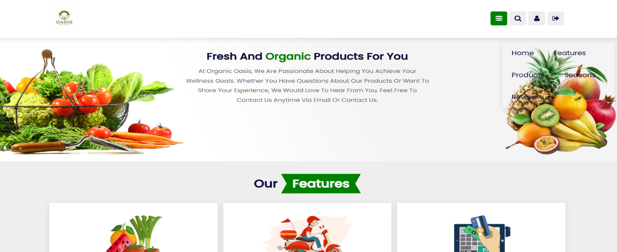This page is the website home page, where you can explore all the wonderful choices and services of our platform has to offer, tailored to meet your fresh and organic produce needs.

### Products & Seasonal Page:

This is the page where a user can find our products availability, seasonal availability, and sourcing details. Whether you're looking to incorporate more organic options into your diet or seeking specific products

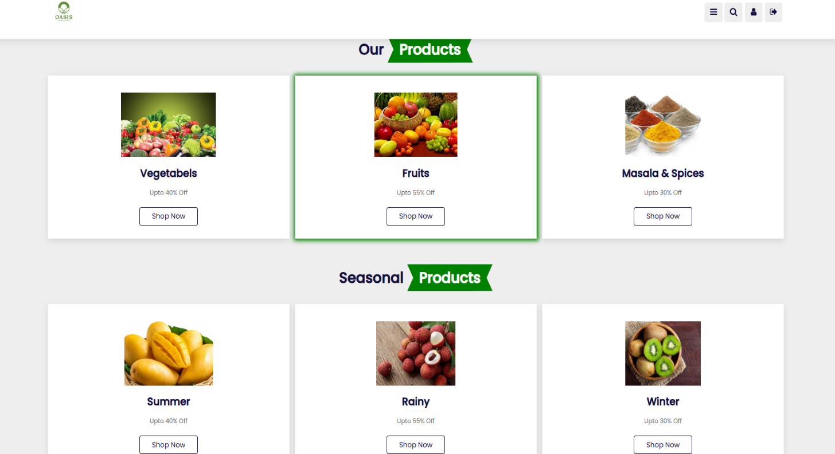

### Login page:

This is the page where an existing user can log in and view all the features of the website.

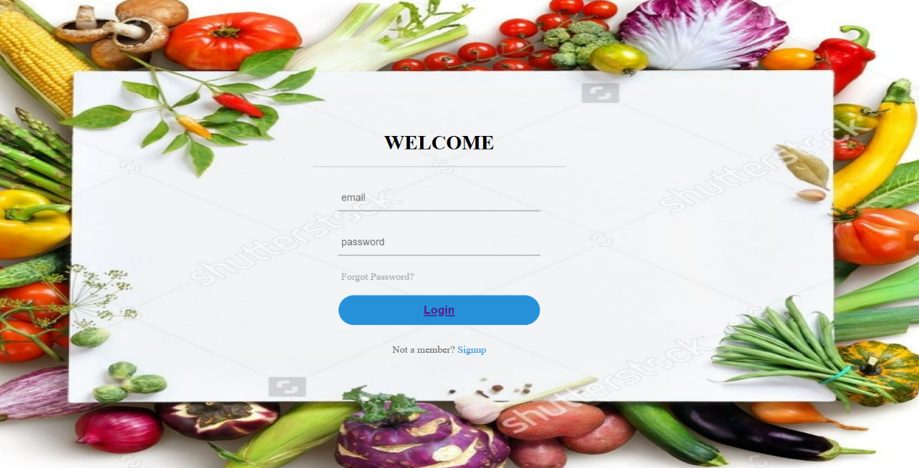

### Registration Page:

If a user is new to the webpage, they can register here and get information about our website that we post and receive newsletters via mail.

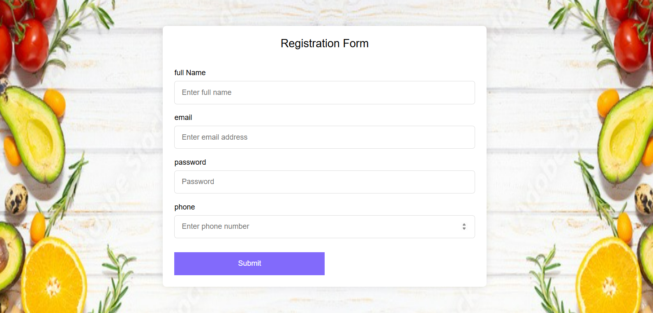

### Oasis overview page:

Once the user select a category of user choice, user will be taken to an overview page that provides detailed insights into the top organic fruits and vegetables available in that category.

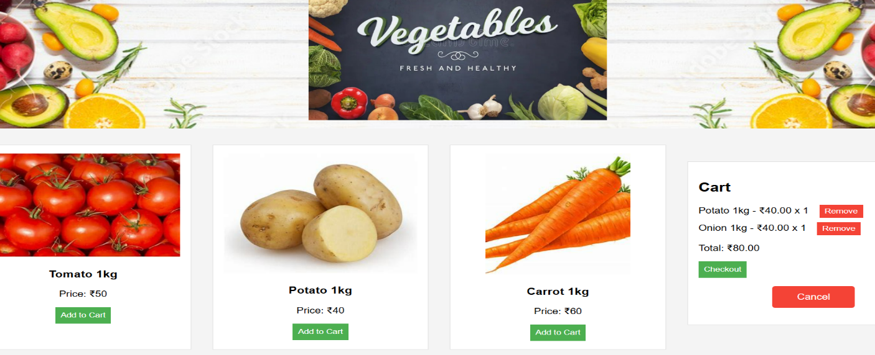

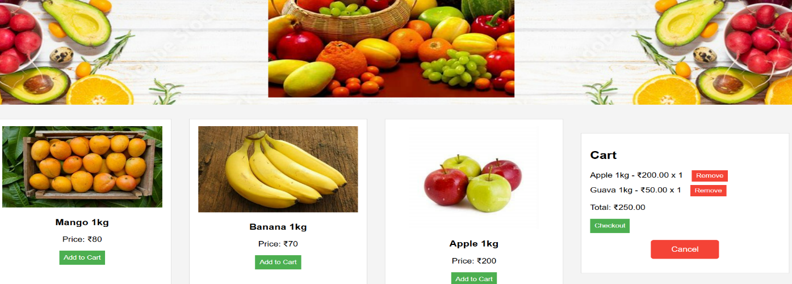

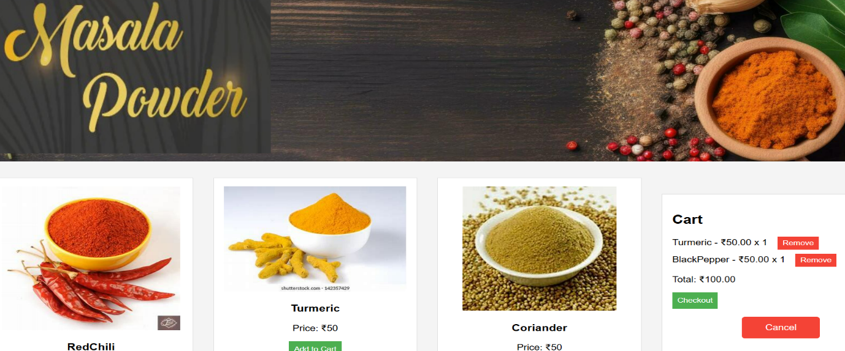

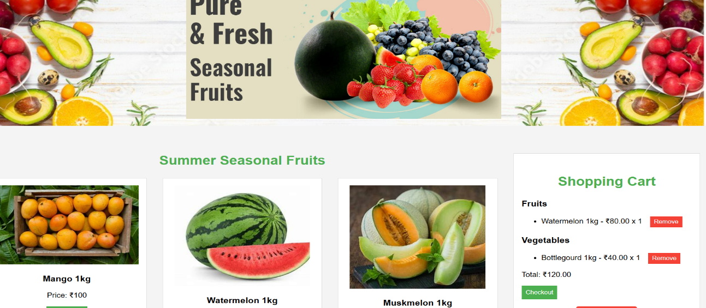

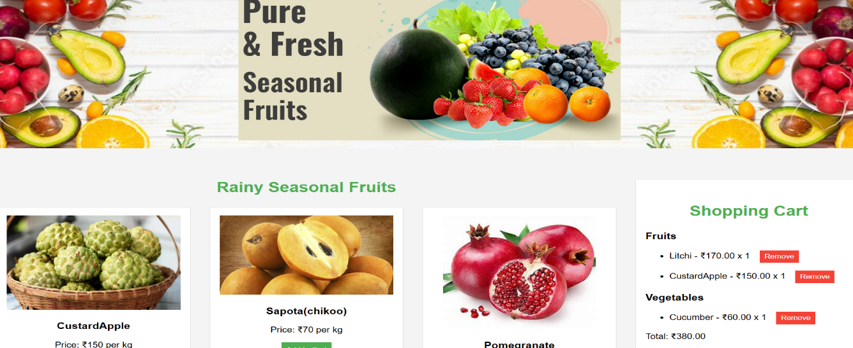

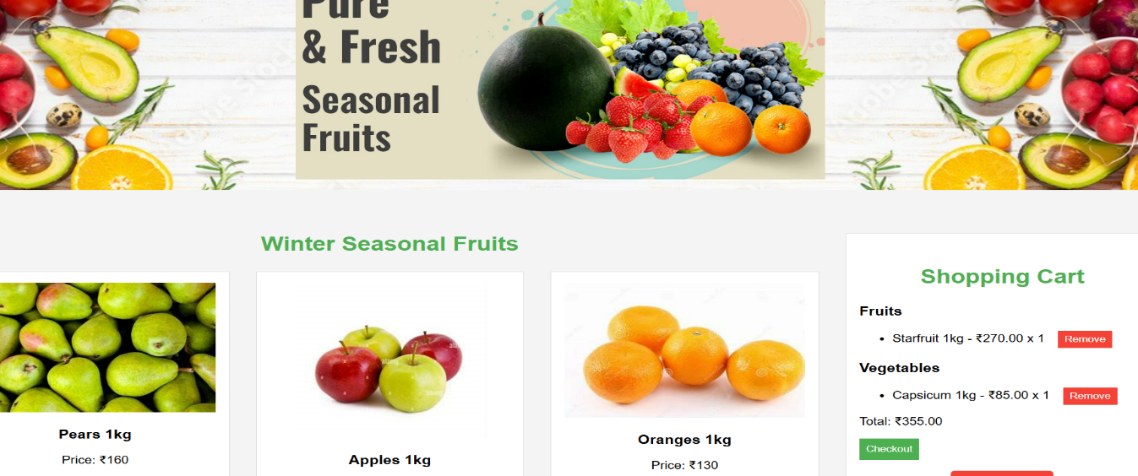

### Cart & Payment explore page:

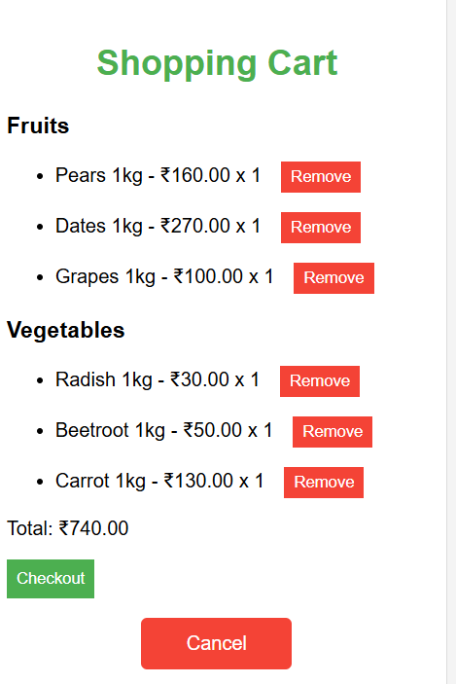

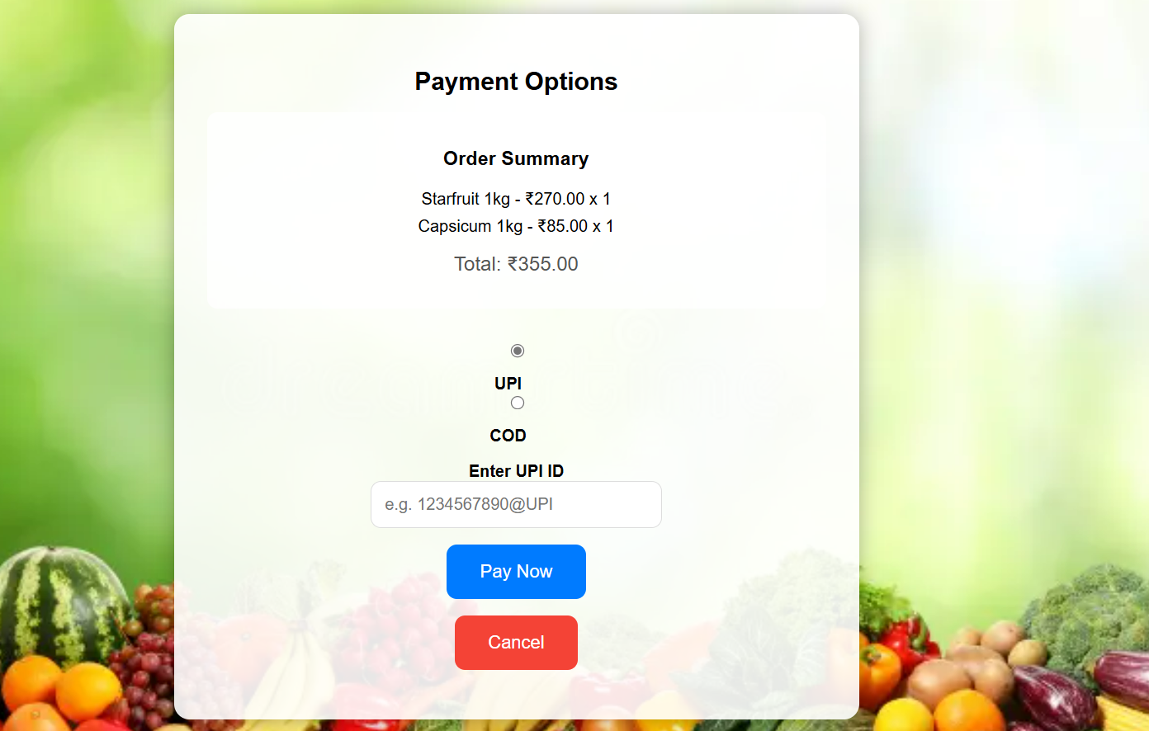

### vi. Contact us Page:

This is the webpage where a user can contact us , if they have any queries regarding anything in our website and leave a message for us.

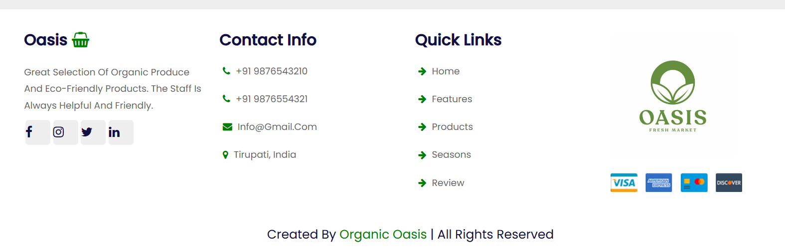

## CHAPTER-7 CONCLUSION ANDFUTURE WORK

### Conclusion:

The website built using modern front-end technologies, provides a comprehensive and interactive platform for users to explore the world of fresh and organic produce. Its intuitive design and detailed information on various fruits and vegetables ensure users can make informed and healthy dietary choices. The engaging and user-friendly interface enhances the overall browsing experience, promoting the benefits of organic eating and sustainable farming practices. By offering valuable insights and easy access to organic produce, Organic Oasis supports healthier lifestyles and fosters environmental consciousness.

### Future Work:

This project offers numerous opportunities for future enhancements. Potential areas for future work include expanding the content by regularly updating and adding more information about various organic fruits and vegetables, including their nutritional benefits, sourcing details, and sustainable farming practices. Integrating multimedia elements such as high-quality images, instructional videos, and interactive guides can further engage users. Implementing user-generated content features like reviews and ratings can foster a sense of community and trust. Developing a mobile application version of the website can cater to users who prefer accessing information on-the-go. Integration with social media platforms and multilingual support can increase reach and accessibility, making the platform more inclusive. Advanced search and filtering options, personalized recommendations, and integration with e-commerce features can enhance the user experience and open up revenue opportunities. Ongoing performance optimization, analyzing user analytics, and staying updated with industry trends are crucial for continuous improvement and maintaining user satisfaction.